**IT - 478 IoT (Internet of Things)   
Central Unit for Irrigation Water Pumps**



Shreemad Patel (201501045)

Yash Patel(201501046)

**Index:**

* Abstract
* Motivation
* Problem Statement
* Prototype
  + Components
  + Circuit Diagrams
  + Flow of execution
  + Issues faced during construction – Solutions
  + Limitations in prototype
* Future Scope / Improvements
* Conclusion

**Abstract :**

Agricultureis the most important sector of Indian Economy. Indian agriculture sector accounts for 18 per cent of India's gross domestic product (GDP) and provides employmentto 50% of the countries workforce.

India has shown a steady average nationwide annual increase in the kilograms produced per hectare for some agricultural items, over the last 60 years. These gains have come mainly from India's green revolution, improving road and power generation infrastructure, knowledge of gains and reforms.

Despite these recent accomplishments, agriculture has the potential for major productivity and total output gains, because crop yields in India are still just 30% to 60% of the best sustainable crop yields achievable in the farms of developed and other developing countries. Additionally, losses after harvest due to poor infrastructure and unorganized retail cause India to experience some of the highest food losses in the world. Issues like damage of crop due to lack of proper irrigation, absence of proper information regarding the crop cycle, soil nutrient level, etc cause decrease in the production of crops.

We aim to tackle the issue of irrigation forming an IaaS (Infrastructure as a Service) platform, a central control unit for water pumps which can be accessed by using remote devices by farmer and adequate amount of water can be provided.

**Motivation :**

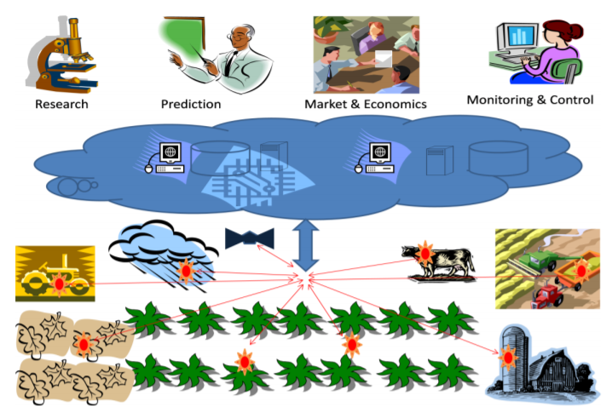

There is also a growing opportunity in the agriculture sector that stands to improve lives, make India a true leader in Agricultural IoT and revolutionize the way farmers plant, fertilize and harvest in the next decade. And the time is right, thanks to advances from chipmakers, that are making the compute and connectivity hardware and software technologies more affordable. This sector can reap the benefits of the huge potential of IoT – driven solutions to improve supply chains and farming practices, which together can have the impact of improved yield and higher monetization for the sector. Large farmers are now deploying ‘Precision Farming’ techniques that use field sensors to monitor farming operations.

Smart irrigation systems are specifically suited for arid and semi-arid regions, smart irrigation technology can ensure efficient use of water resources based on the humidity of the soil, the needs of the crop and weather patterns, which when integrated with the right type of sensors and connectivity will result in optimal usage of a scarce resource.

**Problem Statement :**

Project construction of central control unit for irrigation water pump controller for introducing the automation technology in lives of those villagers who have barely any water supply. It becomes essential for the Farmers who are not that acquainted with the proper knowledge of smart farming to get access to it by putting in very limited number of efforts.

There will be an android App installed in Farmer’s cell phone from where he can send message to the GSM module at the Arduino End which in a way controls the Relay for the flow of water into the farm. The microcontroller takes the responsibility of controlling the water pump using Relay.

**Problems to approach:**

* Maximize the outreach of water to the field by using appropriate infrastructure.
* Make use of minimum power in doing so.
* Update the data of every message request in the database so that data analysis can be performed to make informed decisions in the future.

**Prototype :**

**Components and Technical Specifications:**

* 2 Arduino Uno
  + Operating voltage - 5 V
  + Input Voltage - 7-12 V
  + Digital I/O pins - 14
  + Analog input pins - 6
  + Clock Speed -16MHz
* 1 GSM Module (SIM900A with Antenna)
  + Supply Voltage - 3.0 - 4V
  + Polarization - RHCP
  + Axial ratio - 3dB max
* MicroSD Card Breakout with Output.
* DHT11 Temperature and Humidity Sensor

**Circuit Diagram :**

* Humidity and Temperature Sensor 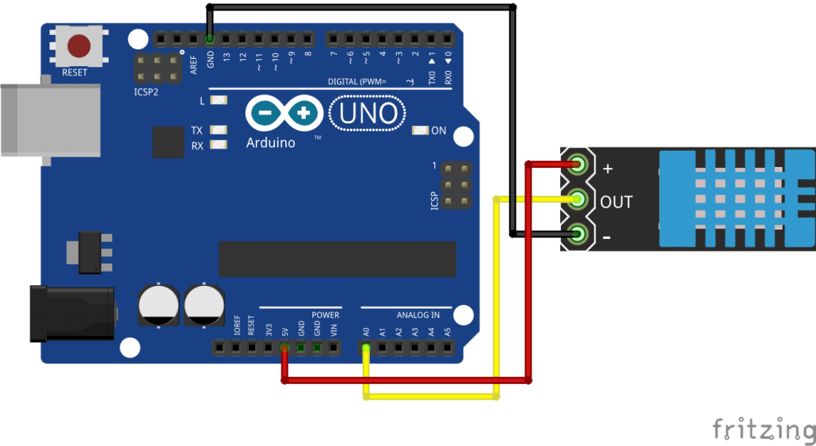
* GSM module Configuration with Arduino -

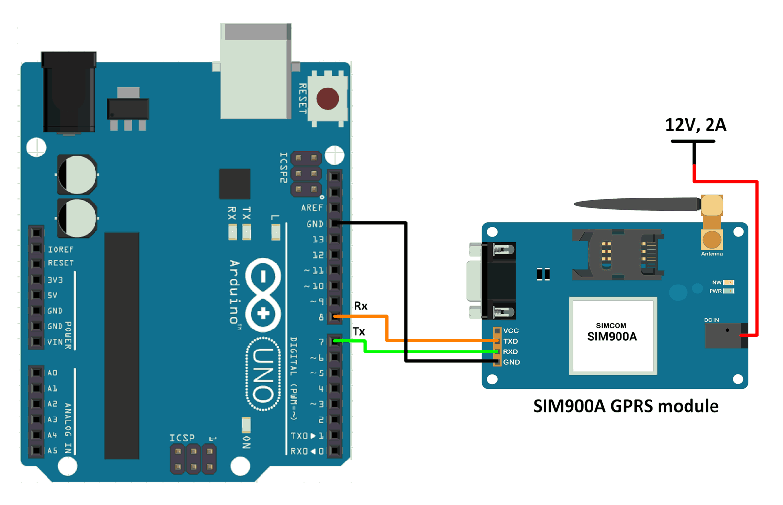

* Water Pump Controlling Transistor swtich Circuit -

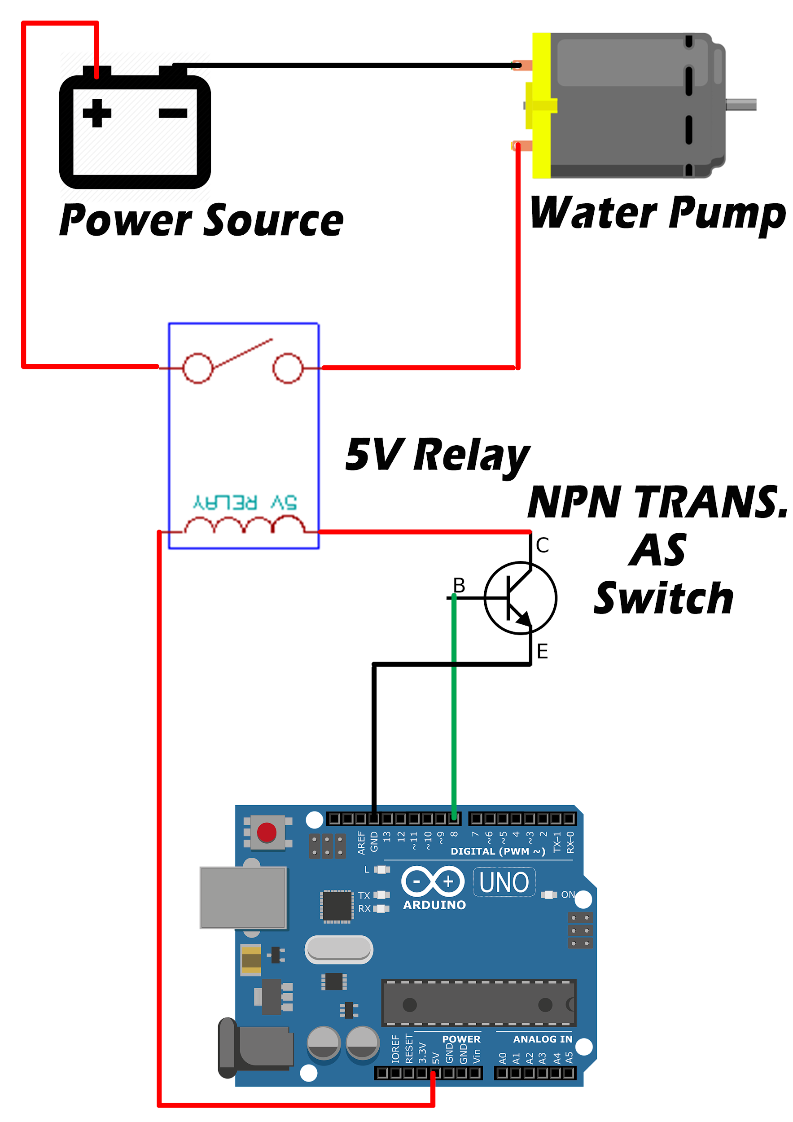

* Memory Card Reader Configuration with Arduino -

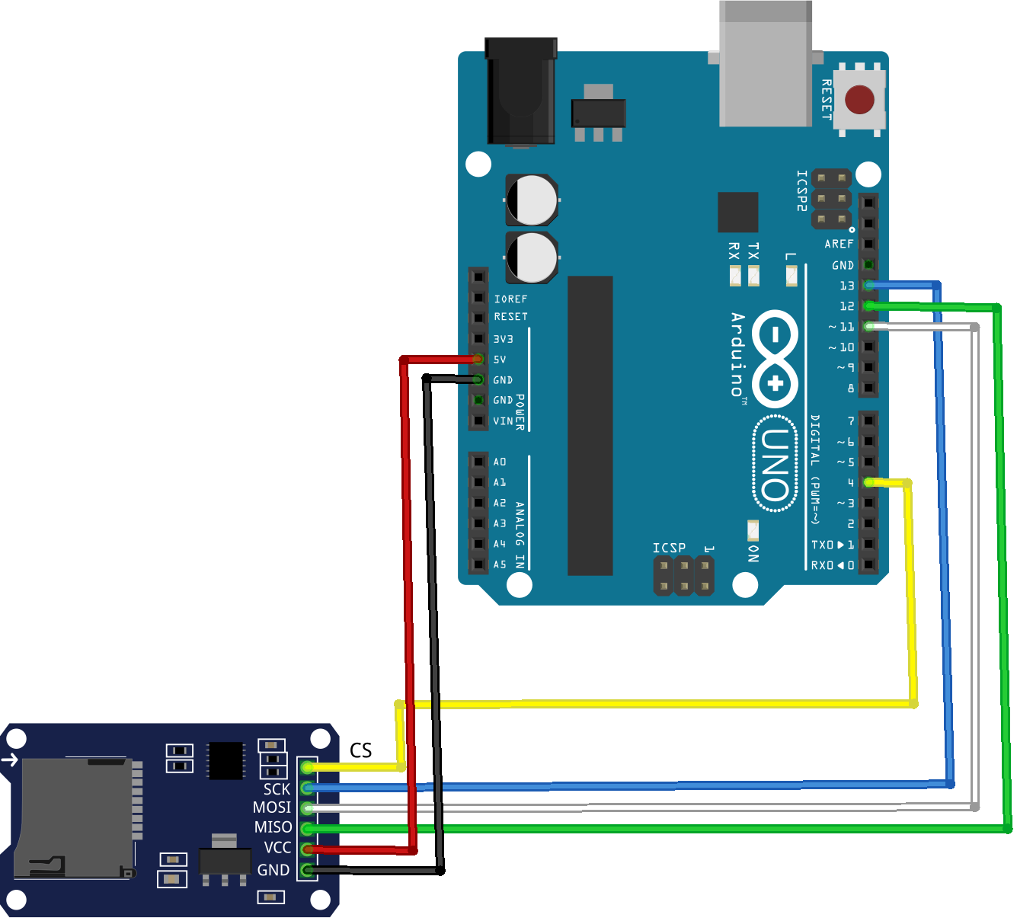

* Android App

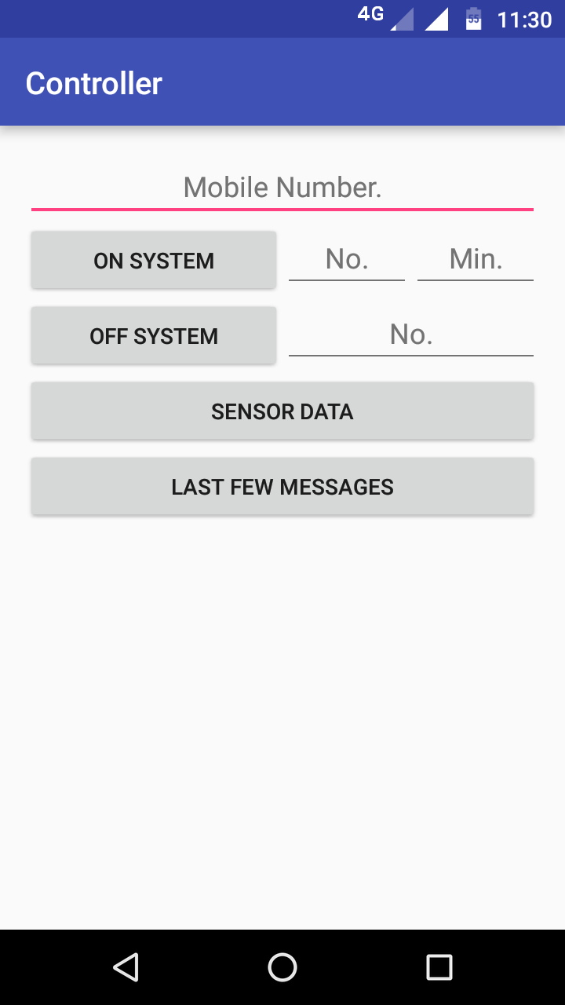

**Circuit Image :**

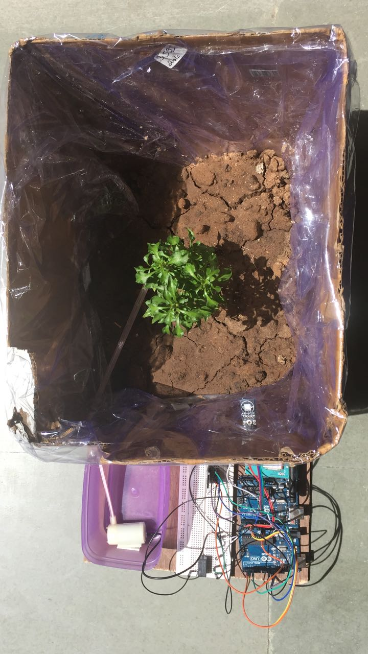

**Flow of execution :**

* Android App installed in Farmer’s cell phone from where he can send message to the GSM module.
* When Farmer sends **# ON : y : x #** message, the pump will be ON for a particular amount of time. Here y denotes the pump number and x denotes the time for which the pump will be ON. After the particular is on, **“all pumps are on”** message is received if no value of y is specified or else, the particular value is sent
* If Off time is not provided, the system will close itself automatically, and if Farmer wants to switch off the Pump, he can send message **# OFF : y #** where y denotes the pump number.
* If Farmer wants to access last few messages to find out the last time the pump was on or the sensor data is received, he can send **# LAST FEW MESSAGES #** . If he wants to view the Humidity and Temperature conditions of the farm, he can send **# SENSOR DATA #** to the SIM at the arduino side of the system. When the Sensor Data is accessed, the Memory card Module also stores the readings along with the messages database.
* Arduino Interface is connected with MicroSD card Reader, GSM module and DHT11 Sensor, and Relay circuit which controls flow of water. When the circuit receives message of starting the water sprinkling, initially DHT11 sensor measures the Humidity values.
* Arduino in a way controls the Relay for the flow of water into the farm. After the completion of water sprinkling, **“all pumps are off”** message is sent to the farmer.
* When the circuit is ON, the DHT11 (Temperature and Humidity) Sensor calculates reading every 1 Hour and stores them into SD card. This is done using the Timer Library in Arduino.

**Issues faced during project :**

* Configuration of GSM Module. We were not able to capture GSM (2G) signal at ground floor due to poor GSM connections. We took it to a location where connectivity was available to be able to use it.
* Due to limited resources and in order to balance load, we used 2 arduinos and also used serial communication between 2 arduinos. I.e. The Rx and Tx pins of the Arduinos are inserted into each other and MySerial method is used to access it.
* When the Pump is being controlled with Relay, it is connected with external power source of 12V Adapter. The Issue faced is that when the motor receives the ON message, it starts but due to consumption of power, the GSM module is not able to access the OFF message send by the farmer, which essentially means that farmer has to send the OFF time in the ON message itself. The whole circuit works fine if Motor is not attached.
* Memory Card module requires Arduino Libraries which take upto 50% of the Arduino’s memory space the reason being size of the SD card libraries. Thus, when the code as a whole is uploaded, the memory is 80% occupied so, the output is not seen and reuploading would mean rewriting in the memory.

**Limitations in prototype :**

* The system currently developed has only one water pump controlled by Relay andhence a small part of the field will be covered.
* This system will work only if there is coverage in the area where the field is located because of the GSM module.
* Use of knowledge base is not done i.e. water flow remains constant for all the crops regardless of how much quantity of water they require.
* The Timer Library used in Arduino to record periodic data of Humidity and Temperature has a disadvantage that on pressing the RESET button in Arduino, the timer starts from the beginning. One solution to this is using the date and time values from GSM module which is difficult to fetch.

**Future Scope :**

* Later, on basis of large dataset and applying knowledge of agriculture sciences, various predictions can be made typically for example what kind of crop can be grown at a particular time, how much amount of water will be required in a particular month, etc.
* The Android App can include features like soil type and plant type, and when a farmer selects a particular option, based on the data analysed, the Arduino can decide the time duration for which the water pump will remain on.
* The same infrastructure can be deployed for the whole farm, using various infrastructure techniques to maximize the outreach of water to the field and minimizing use of power.
* Solar Cell can be added to the system so that the power consumption is lesser. As Indian environment has sufficient amount of heat in the atmosphere, the system might eventually gain enough power that it might not require any external power too.

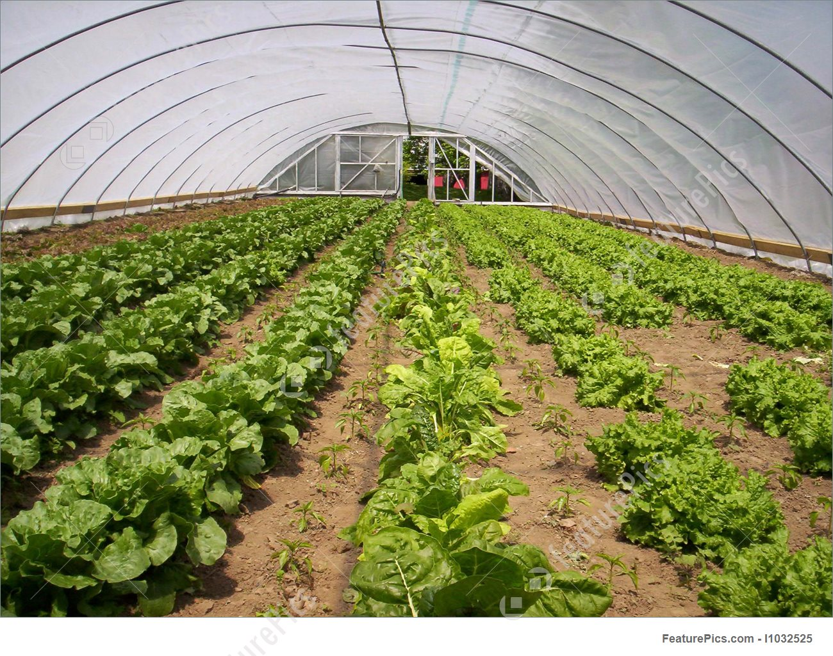

* The current deployment is limited to one plant only, but it can be improved for large size greenhouses wherein each row of plant can have a particular set of sensor which sense data periodically, and send it over to the cloud for different computation to be carried out.
* Furthermore improvements can be done in the Android Application developed, by using the large dataset and ML Techniques, farmers can receive notifications in case the humidity and temperature levels are becoming low than a particular value. So, he/she can remain less stressed about the water needs of plants.

**Conclusion :**

The IaaS (Infrastructure as a Service) system developed using IoT and Information Technology can be really called smart solution. At par with Smart Agriculture initiatives, the system can solve the problem of lack of improper irrigation. The solution does not need too high initial capital investment and is easy to initialise and deploy in Indian Urban Scenario. Also, it can be a boon to the farmers who do not have resources to adopt high cost smart farming techniques.